import pandas as pd
import numpy as np
import matplotlib.pyplot as plt
import scipy.stats as stats
import seaborn as sns
import statsmodels.api as smf
import warnings
warnings.filterwarnings('ignore')

Q1.

Look at the data given below. Plot the data, find the outliers and find out μ,σ,σ^2
Name of company Measure X
Allied Signal 24.23%
Bankers Trust 25.53%
General Mills 25.41%
ITT Industries 24.14%
J.P.Morgan & Co. 29.62%
Lehman Brothers 28.25%
Marriott 25.81%
MCI 24.39%
Merrill Lynch 40.26%
Microsoft 32.95%
Morgan Stanley 91.36%
Sun Microsystems 25.99%
Travelers 39.42%
US Airways 26.71%
Warner-Lambert 35.00%\

measure_x = [24.23,25.53,25.41,24.14,29.62,28.25,25.81,24.39,40.26,32.95,91.36,25.99,39.42,26.71,35.00]
name_of_company = ['Allied Signal','Bankers Trust','General Mills','ITT Industries','J.P.Morgan & Co.','Lehman Brothers',
'Marriott','MCI','Merrill Lynch','Microsoft','Morgan Stanley','Sun Microsystems','Travelers','US Airways',
'Warner-Lambert']
plt.figure(figsize = (8,8))
plt.pie(measure_x, labels = name_of_company, autopct= '%.2f%%',shadow = True,
explode = [0.0,0.0,0.0,0.0,0.0,0.0,0.0,0.0,0.0,0.0,0.1,0.0,0.0,0.0,0.0],
textprops = {'size':'medium',
'fontweight':'bold',
'color':'black'})
plt.title('Name of Companies with respect to X', fontsize = 18, fontweight = 'bold', color='b')
plt.savefig('Question1piechart.png')
plt.show()
plt.figure(figsize = (10,9))
ax = sns.barplot(y = measure_x, x = name_of_company, edgecolor='black')
plt.xticks(rotation = 90, fontsize = 12, fontweight = 'bold')
for i in ax.containers:
ax.bar_label(i,)
plt.show()
sns.boxplot(measure_x)
plt.savefig('question1boxplot.png')
plt.show()
measure_x=pd.Series(measure_x)
Q1 = np.quantile(measure_x,0.25)
Q3 = np.quantile(measure_x,0.75)
med = np.median(measure_x)
IQR = Q3 - Q1
upper_bound = Q3+(1.5*IQR)
lower_bound = Q1-(1.5*IQR)
print('First Quantile=', Q1, 'Second Quantile=', med, 'Third Quantile=', Q3,
'Inter-Quartile Range=', IQR, 'Upper Whisker=', upper_bound, 'Lower Whisker=', lower_bound)
Outliers = measure_x[(measure_x <= lower_bound) | (measure_x >= upper_bound)]
print('The outlier in the boxplot:',Outliers)
Outliers = measure_x[(measure_x >= upper_bound)]
print('The outlier in the boxplot:',Outliers)
print(measure_x.describe())
print("Variance=",measure_x.var())

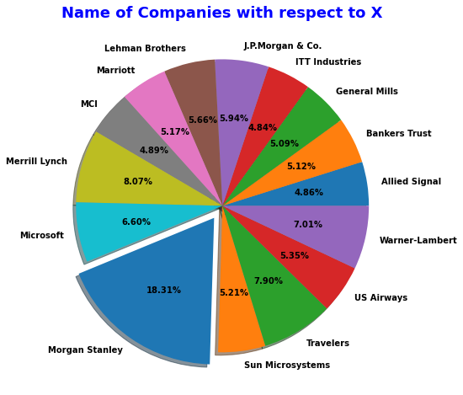

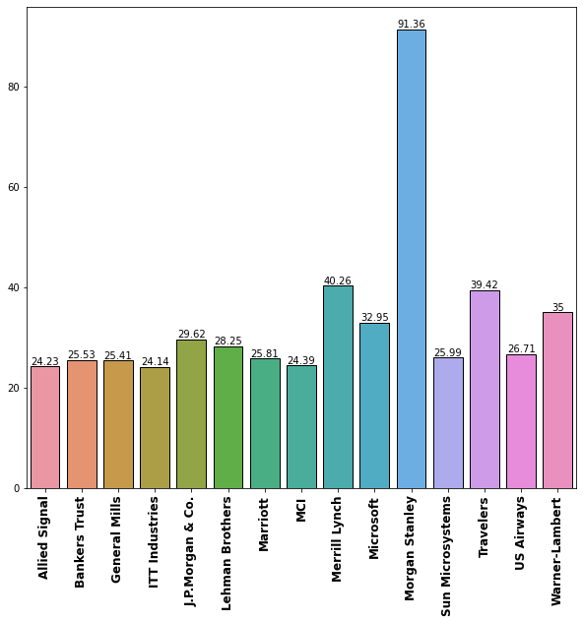
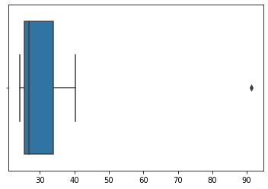

First Quantile= 25.47 Second Quantile= 26.71 Third Quantile= 33.975 Inter-Quartile Range= 8.505000000000003 Upper Whisker= 46.7325 Lower Whisker= 12.712499999999995
The outlier in the boxplot: 10 91.36
dtype: float64
The outlier in the boxplot: 10 91.36
dtype: float64
count 15.000000
mean 33.271333
std 16.945401
min 24.140000
25% 25.470000
50% 26.710000
75% 33.975000
max 91.360000
dtype: float64
Variance= 287.1466123809524

Q2.
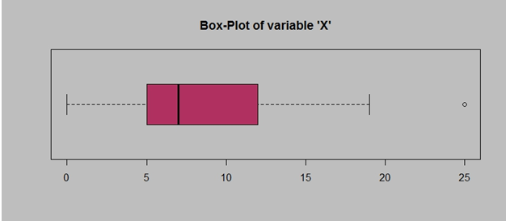Answer the following three questions based on the box-plot above.

==>
  - ) What is inter-quartile range of this dataset? (please approximate the numbers) In one line, explain what this value implies.
Ans:

Approximately (First Quantile Range) Q1 = 5 (Third Quantile Range) Q3 = 12, Median (Second Quartile Range) = 7 (Inter-Quartile Range) IQR = Q3 – Q1 = 12 – 5 = 7 Second Quartile Range is the Median Value.

2. ) What can we say about the skewness of this dataset?
Ans:
Right-Skewed median is towards the left side it is not normal distribution

3. ) If it was found that the data point with the value 25 is actually 2.5, how would the new box-plot be affected?
Ans:
In that case there would be no Outliers on the given dataset because of the outlier the data had positive skewness it will reduce and the data will normal distributed

Q3.
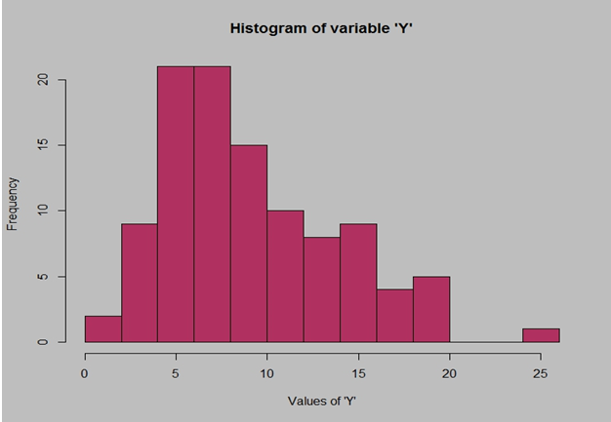.

Answer the following three questions based on the histogram above.

1.) Where would the mode of this dataset lie?
Ans:
he mode of this data set lie in between 5 to 10 and approximately between 4 to 8 .

2. ) Comment on the skewness of the dataset.
Ans:
Right-Skewed. Mean>Median>Mode

3. ) Suppose that the above histogram and the box-plot in question 2 are plotted for the same dataset. Explain how these graphs complement each other in providing information about any dataset.
Ans:
They both are right-skewed and both have outliers the median can be easily visualized in box plot where as in histogram mode is more visible.

Q4.
AT&T was running commercials in 1990 aimed at luring back customers who had switched to one of the other long-distance phone service providers. One such commercial shows a businessman trying to reach Phoenix and mistakenly getting Fiji, where a half-naked native on a beach responds incomprehensibly in Polynesian. When asked about this advertisement, AT&T admitted that the portrayed incident did not actually take place but added that this was an enactment of something that “could happen.” Suppose that one in 200 long-distance telephone calls is misdirected. What is the probability that at least one in five attempted telephone calls reaches the wrong number? (Assume independence of attempts.)

Ans:
IF 1 in 200 long-distance telephone calls are getting misdirected.
probability of call misdirecting = 1/200 Probability of call not Misdirecting = 1-1/200 = 199/200 The probability for at least one in five attempted telephone calls reaches the wrong number Number of Calls = 5 n = 5 p = 1/200 q = 199/200 P(x) = at least one in five attempted telephone calls reaches the wrong number P(x) = ⁿCₓ pˣ qⁿ⁻ˣ P(x) = (nCx) (p^x) (q^n-x) # nCr = n! / r! * (n - r)! P(1) = (5C1) (1/200)^1 (199/200)^5-1 P(1) = 0.0245037

Q.5

Returns on a certain business venture, to the nearest $1,000, are known to follow the following probability distribution

1.) What is the most likely monetary outcome of the business venture?

Ans:
The most likely monetary outcome of the business venture is 2000$ As for 2000$ the probability is 0.3 which is maximum as compared to others

2.) Is the venture likely to be successful? Explain

Ans:
Yes, the probability that the venture will make more than 0 or a profit p(x>0)+p(x>1000)+p(x>2000)+p(x=3000) = 0.2+0.2+0.3+0.1 = 0.8 this states that there is a good 80% chances for this venture to be making a profit

3.) What is the long-term average earning of business ventures of this kind? Explain

Ans:
The long-term average is Expected value = Sum (X * P(X)) = 800$ which means on an average the returns will be + 800$

4.) What is the good measure of the risk involved in a venture of this kind? Compute this measure

Ans:
The good measure of the risk involved in a venture of this kind depends on the Variability in the distribution. Higher Variance means more chances of risk Var (X) = E(X^2) –(E(X))^2 = 2800000 – 800^2 = 2160000

